
FreeAgent
Software Accreditation February 2019

Company Background

FreeAgent Central Ltd was founded by Ed Molyneux (CEO), Olly Headey (CTO) and Roan Lavery (Product Director) and incorporated in February 2007.
FreeAgent Central's cloud-based business accounting solution is their primary offering, so the company is not distracted by other revenue streams.
Based in Edinburgh FreeAgent is UK based and remains focussed on a solution that is tailored to UK markets. After being acquired by Royal Bank of Scotland group in March 2018 the continuous development of the software has continued, with a user interface redesign being launched in September 2018.
FreeAgent have won two Awards in the last couple of years:
Winner: 2018 Accounting Excellence Awards, Small Business Accounting Software of the Year
Winner: 2017 Software Excellence Awards, SME accounts/bookkeeping
The Product
This review is based on the service as at February 2019. There are three options (excluding VAT) and at the time of writing this review there is a new customer offer of 50% off the prices quoted below for the first six months:
Sole Trader £19 per month This includes self-assessment filing.
Partnerships / LLPs £24 per month This includes a profit-share calculation.
Limited Companies £29 per month This includes Director self-assessment filing, dividend vouchers and corporation tax forecasting
Unlimited everything – you can have as many users, clients or projects at no extra cost. There is no extra charge for payroll. If you pay up-front then you get 12 months for the price of 10 months.
FreeAgent is currently provided free for clients who have business bank accounts with NatWest Bank or Royal Bank of Scotland.

FreeAgent offer special pricing to Accountants / Bookkeepers based on the number of active clients they have on FreeAgent. The Accountants/Bookkeeper's dashboard is set up free of charge and comes with full functionality. FreeAgent does not ask you to bulk buy licenses or pay upfront, the pricing is very much “pay as you go” - you only pay for the number of licenses you have active on your dashboard at any time which means the Accountant / Bookkeeper is in control of the cost.

The current pricing tiers for Accountants / Bookkeepers are as follows:
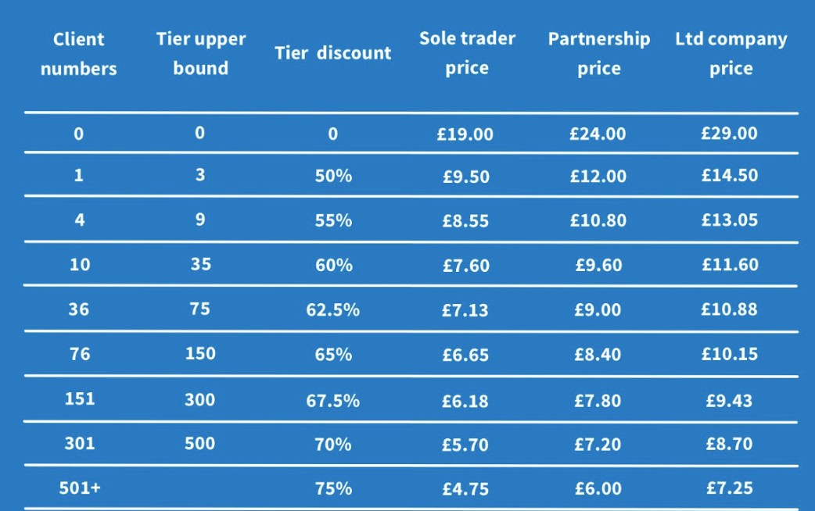
FreeAgent Contact Details
Address: Email:
One Edinburgh Quay support@freeagent.com
113 Fountainbridge practicesupport@freeagent.com
Edinburgh
EH3 9QG General: hello@freeagent.com
Media: press@freeagent.com
Practice sales: accountants@freeagent.com
Phone: http://www.freeagent.com
Support: 0800 288 8691
Accountants: 0800 025 3800
Practice sales: 0800 025 3900
Head Office: 0131 447 0011
Key Benefits (as advertised)
- Making Tax Digital compliant
- Snap an expense, fire off an invoice, check your cash flow, stay on top of your tax.
- Take care of business, anywhere.
- No more mess – invoicing, expenses and more all in one place
- One tidy dashboard that gives you an overview of your whole business
- Take a weight off with automatic tax forecasts and reminders

Estimates and invoices – send and track professionally designed estimates and invoices

Expenses – never lose a receipt, simply snap a photo with your phone and upload

Time tracking – record all your time with the in-built stopwatch or smart timesheets

Self-Assessment – fill and file your self assessment tax return directly to HMRC

VAT – review automatically generated VAT returns and file with a single click

Corporation Tax – forecast your Corporation Tax bill ahead of time to avoid any nasty surprises

Dashboard – monitor cash flow at a glance and see when your tax bills are due

Banking – connect FreeAgent to your bank accounts to automatically import transactions

Projects – a bird’s eye view of the performance of your income, expenses and profitability

Using the software
Having signed-up to FreeAgent you are prompted to enter your business type, details and accounting dates, VAT details (dates, scheme and number) followed by your bank account information so that electronic statements can be uploaded automatically. If you do not wish to include your bank details straight away, this may be configured later, as can credit cards and PayPal accounts – it is worth noting that these can be multi-currency. You can then upload your company logo so that invoices and estimates are branded to your business if desired – this can be easily actioned through the Settings menu. Having completed these steps, the fundamentals are in place.
New clients are easy to set up through the Accountant dashboard – these can either be set up as active or inactive clients (inactive clients are not billed) and if the clients have business bank accounts with NatWest Bank or Royal Bank of Scotland then their account details just need to be added when setting up the client to ensure they are not charged separately.
You will then need to enter any opening balances. This can be achieved using Journal entries from the “Accounting” menu. Each balance will have to be entered separately with the opposite entry being automatically posted to a suspense account. Until the accounts balance, a warning is shown whenever you enter the Journal Entries area that you have unbalanced entries. The opening balances can easily be amended later if required.
Account names for income and expenditure can be easily edited using the Settings menu (under Income and Spending Categories from within the Accounting, Tax and VAT section). This enables the Chart of Accounts to be personalised to the client’s requirements.
The next section you may wish to complete is your business contacts (customers and suppliers). FreeAgent can import contacts using the popular 'vCard' format or alternatively from Outlook using comma separated values. A link is available from the FreeAgent screen to help you export your contacts from Outlook, Google Mail, Apple Mail and FreshBooks. Alternatively, you can simply click a “Create Contact” button and enter the details manually – the screen to do this is intuitive and easy to follow. This mechanism also lets you set appropriate defaults relating to charging VAT and displaying customer VAT numbers on your invoices and automatically generating sequential invoice numbers.
Having entered your contact details, you can then enter all customer and supplier invoices. FreeAgent also recommends when to simply enter payments made for goods and services that are not from a credit supplier, as well as business expenses incurred that may have been settled personally. There is the ability to set up recurring invoices which is good for regular invoices to ensure they are not missed or issued late.
FreeAgent can also be used to generate estimates. Depending on your business type, you may also find the “Project” facility of FreeAgent useful; whereby all costs relating to a piece of work including supplier invoices and time spent by your business on the project are tied together. By linking your customer invoice to the project, you can also see the profitability of the project.
It should be becoming clear that FreeAgent offers a wide range of services and options. To give you an idea, here is the “Settings” screen where you can choose how these options are configured:

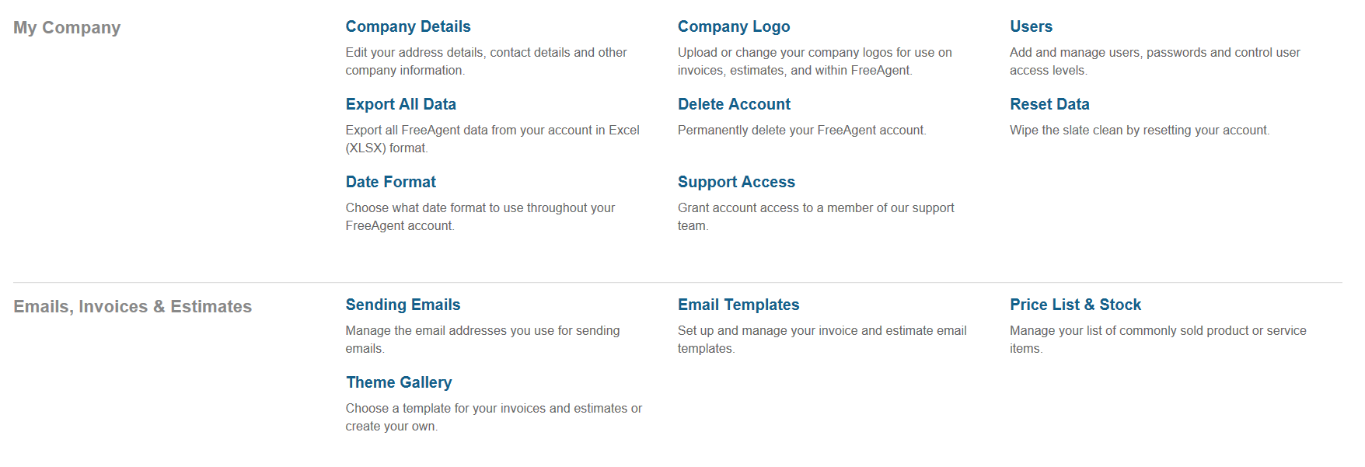
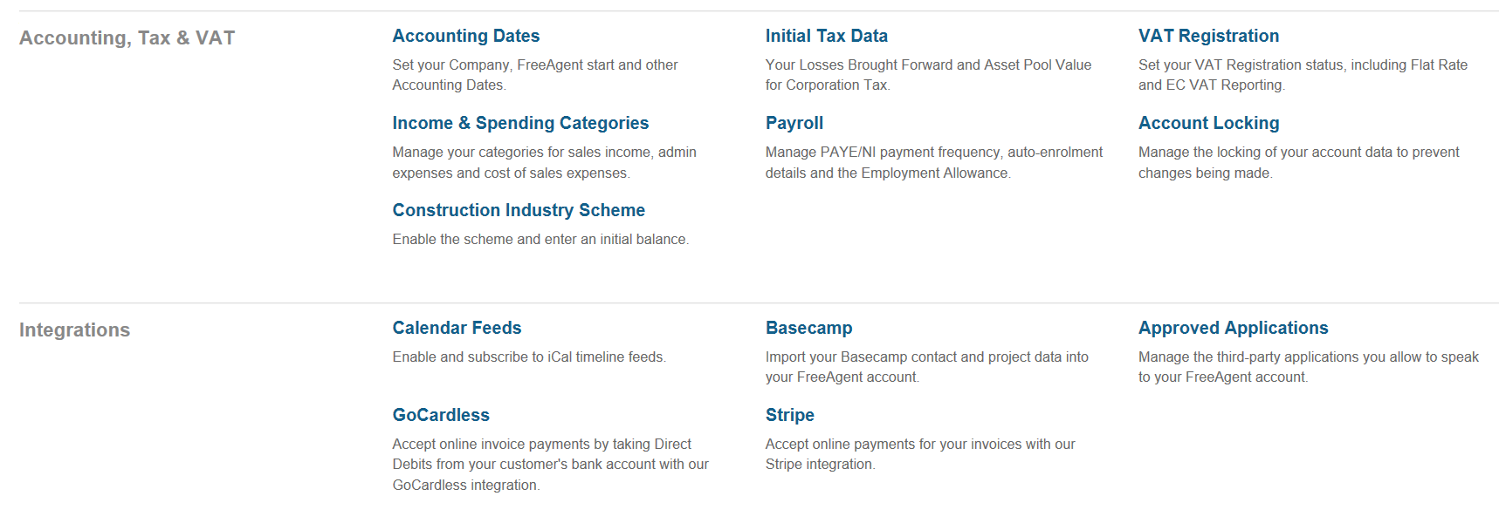
Figure 1 – FreeAgent Settings screen

Having entered opening balances, customers, suppliers, invoices, bank details and payment transactions you have largely completed the basic bookkeeping activities required to produce an up-to-date trial balance. This and other reports that are available can be found under the Accounting menu – these are separated out into High Level, Breakdown and Detailed. Within each report you can choose the ‘View’ to a specific period or by Accounting Period, and the key reports such as Profit and Loss, Balance Sheet, Aged Debtors / Creditors and Trial Balance can be easily exported to excel and PDF. A full list of the available Reports is shown on the screenshot below:
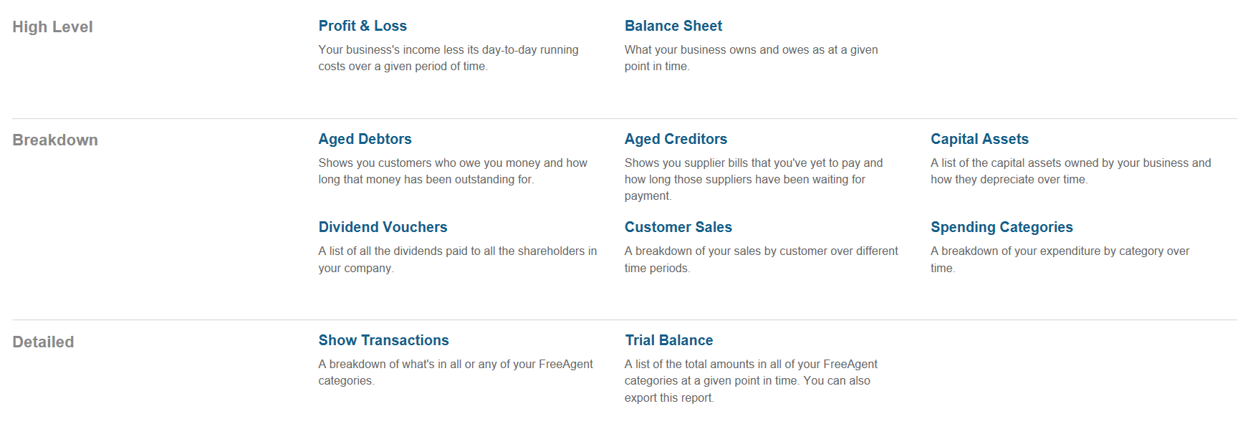
Figure 2 – FreeAgent Reports screen

There is a user-friendly dashboard which can be accessed through the Overview menu – this gives a snap shot of key information such as cashflow, banking, profit and loss, tax timeline, and invoices and bills with a breakdown of overdue, due and paid. There are quick links on this screen to enable you to add an invoice, add an expense, upload a statement as well as buttons to take you to the individual screens to view all bank accounts, view the profit and loss in full, view all invoices and view all expenses. A screen shot example of the Overview page is below:

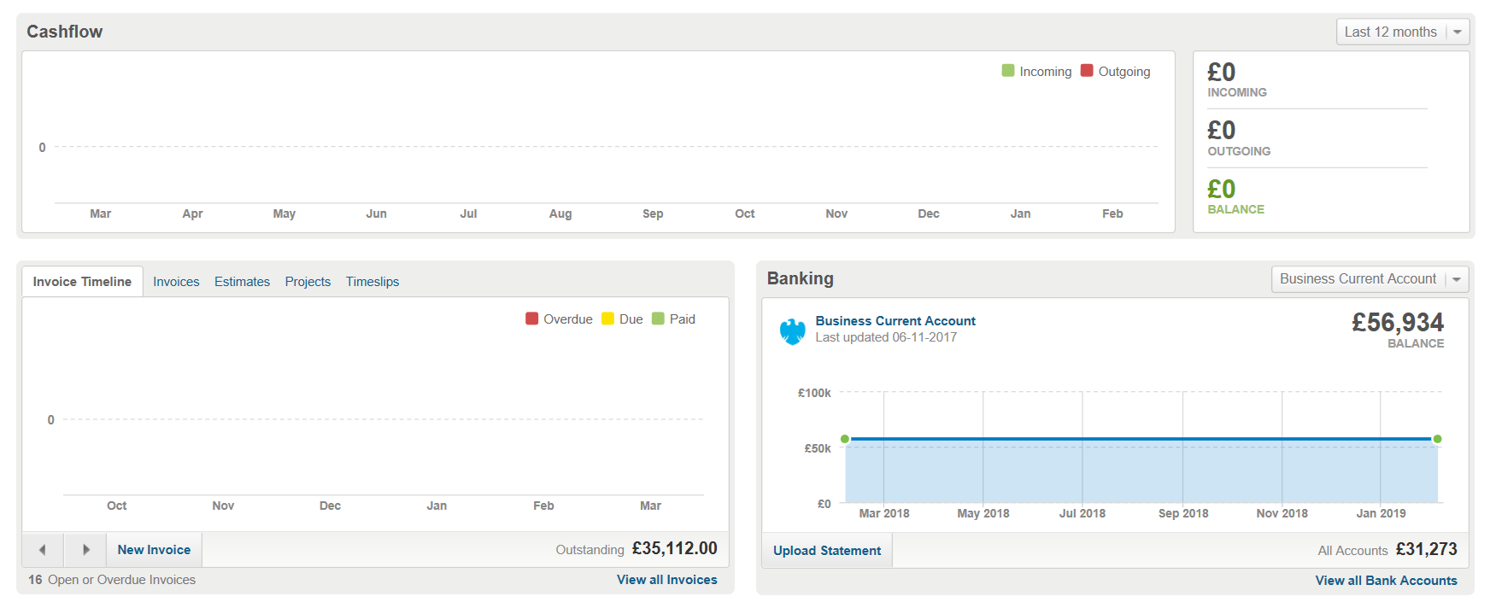
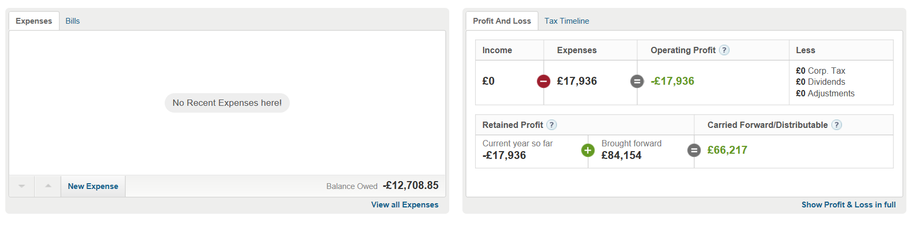
Figure 3 – Dashboard of charts in Overview
The Taxes menu enables you to access the VAT Return, showing both a Return Preview and Full Report for the period. There is the ability to edit the VAT settings on this screen. If there are unexplained (unreconciled) entries on the bank account for the VAT period then you will get a warning appear so you can review these transactions before filing the return. The return can be submitted online to HMRC, and it is worth noting that FreeAgent are Making Tax Digital (MTD) compliant for returns due after 1st April 2019. The MTD process also looks very easy to follow, with Settings in the Accountant dashboard just needing to be updated with the new HMRC Agent Services Account details (in addition to the client being registered for MTD submissions) and this will enable MTD returns to be submitted easily in FreeAgent.
Monthly payroll can easily be set up and processed through FreeAgent with this being HMRC compliant – this includes CIS for contractors and the ability to mark projects which are captured under IR35. The payslips are easy to amend including adding any overtime, bonus or Statutory items such as Statutory Sick Pay. Accountants have the ability to process payroll for all of their FreeAgent clients in bulk, making this very quick and easy to do. The Taxes tab shows transactions relating to PAYE / NI that are due and the tax timeline is a helpful reminder as to when tax liabilities are due with this being able to be linked up to a google or outlook calendar (as well as appearing on the Overview screen).
In addition to the online version, you can also access FreeAgent via an App. The App allows you to easily enter expenses, mileage, invoices, estimates, bills and contacts. With expenses, mileage and bills you can easily add an attachment by taking a photo of the receipt / purchase invoice. You can access your banking screen via the App, and also see the Tax Timeline detailing when tax liabilities are due.
The Accountant dashboard has additional features such as enabling Alert Rules to be set up which is useful for example VAT return due within X days, Director Loan Account exceeds Y, or transaction value is over a certain amount. These can also be set up if users haven’t logged on for a certain period, or if the number of unexplained transactions exceeds X so that the Accountant can easily keep track of the clients and can then contact them as required. The dashboard includes the ability to process bulk payroll which can save time if dealing with a number of clients, and also allows cross client reporting. A number of resources are provided for Accountants / Bookkeepers including marketing content and webinars.

FreeAgent integrates with a large number of add-on systems such as Receipt Bank, AutoEntry, Float and Capsule.
Strengths
It is very easy to sign-up to FreeAgent with a 30-day free trial and no credit card details are required. The company aims to make bookkeeping / accounting for small businesses simple and to enable transactions to be entered without needing to understand a complex chart of accounts. FreeAgent succeeds in this goal.

Support is free, friendly and efficient and there is a live help facility during working hours, with access to accountants, which should mean that all users can enter their business transactions effectively. The online help resources which FreeAgent have available are extremely helpful and easy to follow, showing processes in simple terms with screen shots to explain processes as required. FreeAgent have produced a suite of infographics covering topics such as ‘How to calculate working from home costs’ and ‘Can you claim tax relief on your clothing’ which are also very helpful and easy to follow.

The software also enables accounting / bookkeeping practices to manage their FreeAgent clients and has an 'accreditation' facility whereby accredited practices may be entered into an accountant directory so that FreeAgent users who require a bookkeeper or Accountant can view practice details. This facility can help practices to increase their number of clients. The Accountant dashboard is personalised to the practice which is a nice touch, and a demo company is provided which is good to use for trying the different features and the accreditation.

The software enables sole traders and Directors to complete and file their Self Assessment Tax Returns through FreeAgent which is a good feature, although this has some restrictions (see under weaknesses). Limited Companies have the ability to see a forecast of their Corporation Tax which is great for budgeting and managing cashflow.

The time tracking feature is good, enabling a client to track their employees time on a project or piece of work, with the option to then add this to invoices to re-bill that time as required. When time is being tracked for an individual you can access this from any screen in FreeAgent, so can easily stop or review the time without being on that specific screen.

Payroll can be processed through FreeAgent including CIS, with a handy record to show any tax liabilities including PAYE and National Insurance – there is no additional cost for payroll at the current time. There is the ability to link the tax liabilities to an external calendar such as google and outlook so that the user can ensure deadlines are met. Mileage can also be easily entered as an expense for any employees including the ability to enter a recurring mileage if required.

Additional users can be added easily (no limit on the number) and access levels are set based on a sliding scale from 0 (no access) to 8 (full access) with each level giving an easy to understand description as to what is and isn’t allowed under this authorisation level.

All data can be exported from FreeAgent into excel, which is a really useful feature. This can be downloaded as one excel document with separate tabs for banking, invoices, VAT etc – if there is a lot of data in FreeAgent to download then you can carry on working on other screens whilst it completes the download, and you will then receive an email when it is completed which is a nice touch. This is particularly useful for Accountants when preparing year end accounts and tax returns.

As FreeAgent is under continuous development with new features and updates being applied automatically which is good. You always remain on the latest version, but this also means that the interface may not remain consistent over time. However with the support guides and team there is always a helping hand there to provide guidance on new features or changes if required.

Weaknesses
The ability to file Self-Assessment Tax Returns for sole traders and Directors is a great feature, however some pages of the return are not currently supported such as Property or Foreign Income, so if the individual has these then the return can not be filed direct from FreeAgent.
Payroll can be processed through FreeAgent although this is limited to just a monthly payroll at this time, so won’t necessarily suit every client’s needs.
The Alert Rules on the Accountant dashboard are useful, but some additional categories might make this even more valuable, for example clients turnover exceeding the VAT threshold in a 12-month period.
As with any cloud-based Accounting Software you need a reliable internet connection and suitable means to access FreeAgent, and the ongoing fees mean that you are tied to paying for the service on an ongoing basis, as opposed to a one-off fee with desktop software which is yours to use for as long as you like. It is also possible that having subscribed to FreeAgent the fees may increase.
A common issue with most cloud-based accounting packages including FreeAgent is that it is not easy to import data from other accounting packages, similarly exporting data into a format that is accepted by other packages is not easy. For this reason you are fairly tied in once you have migrated to FreeAgent and could only easily migrate away after year end accounts have been prepared. That said there is a facility to export your data into an Excel Spreadsheet that has tabs for different types of transactions. This is a good means of ensuring that you do not miss anything should you choose to migrate.

Value for Money
The price of the various options for FreeAgent is comparable with other cloud-based accounts services. Free support and unlimited users are a definite benefit, as is the fact that there is no additional charge for payroll – you pay one clear price for the software and are charged on the number of active licences on your dashboard.

Testimonials (from reviews.co.uk)
“Brilliant system, really easy to use and make sense to a non Accountant. Couldn’t do without it now”
“Excellent helpdesk support, very prompt reply and very polite, speedy and helpful response. Followed up very quickly too”

Tweets from users:
“How did I freelance for 10 yrs without @freeagent? Book-keeping a breeze, auto invoice chasing and my support email answered in 32 minutes”
“My best business investment to date... @freeagent! I'm saving myself 4-6 hours a month now my accounts are online.#bookkeeper #mtd”
“Really impressed with @freeagent customer support, fantastic service, really helped me get everything straight in my account!”
Summary of Review
The FreeAgent accounting service has been around for a number of years and is growing in popularity with new interfaces and add-ons being released. The development over the last couple of years has made it a very comprehensive offering with an intuitive interface, and as the feedback shows users find it easy to use. In my view the software is client friendly, easy to understand both the inputs and outputs, and the feedback from users confirms this. The online resources from FreeAgent provide excellent support for both clients and Accountants. The App is user friendly and makes adding expenses and issuing invoices on the go easy.
The Accountant dashboard helps manage clients, with bulk payroll and the ability to set up Alert Rules. The software is Making Tax Digital compliant which is essential for any accounting software as we get closer to April 2019.
It is reasonably priced with a no-obligation free trial and should definitely be considered when evaluating your options for bookkeeping / accounting solution.

Disclaimer
The Institute of Certified Bookkeepers having reviewed the FreeAgent software as supplied in February 2019 cannot be held responsible in any way for the actions of the company, FreeAgent Central Ltd or their software. This review is merely an unbiased overview of the software package. Any enquiries should be directed to support@freeagent.com

